**Project-2 Report On**

**“BREAST CANCER DETECTION”**

In partial fulfilment of requirements for the degree of

**Bachelor of Technology (B. Tech.) Computer Science and Engineering**

**Submitted by:**

Manvi Vrati (190136)

Pranjal Tulsiyan (190119)

Saloni Chawla (190078)

**Under the Guidance of-**

Mr. P K Bisnoi

*Department of Computer Science and Engineering*

**SCHOOL OF ENGINEERING AND TECHNOLOGY**

**Mody University and Science and Technology Lakshmangarh, Distt. Sikar-332311**

22nd April 2022

**ACKNOWLEDGEMENT**

I take this opportunity to express our profound gratitude and deep regards to the people who have been instrumental in the successful guidance for this project. I would like to thank my project guide **Mr. P.K. Bisnoi** for his exemplary guidance, monitoring and constant encouragement throughout the course of this project. The blessings, help, guidance and undivided attention given by him from time to time shall carry us a long way in the journey of life on which we are about to embark.

I am much obliged to **Dr Prateek Bhanti**, (Dean-SET) who has provided me with the best facilities and atmosphere for the project completion and presentation. I am always grateful towards my parents for supporting me in tough times. I would also like to thank all the team members involved in the development of this project as without their support, I would not be able to grasp everything so fast. Together we have completed the project and made it successful. Last but not least, we thank God Almighty for his choicest blessings showed on me in completing this!

**Saloni Chawla [190078]**

**Pranjal Tulsiyan [190119]**

**Manvi Vrati [190136]**

**CERTIFICATE**

This is to certify that the project-2 report entitled “**Breast Cancer Detection**”, submitted by Ms. **Saloni Chawla, Pranjal Tulsiyan and Manvi Vrati**, as a partial fulfilment for the requirement of B. Tech. [Computer Science and Engineering], 6th Semester examination, of the School of Engineering and Technology, Mody University of Science and Technology, Lakshmangarh, for the academic session 2021-2022 is an original project work carried out under the supervision and guidance of **Mr P.K. Bisnoi** has undergone the requisite duration as prescribed by the institution for the project work.

**PROJECT GUIDE: HEAD OF DEPARTMENT**

**Signature: Signature:**

**Name: Name:**

**Date: Date:**

**EXAMINER-I: EXAMINER-II**

**Signature: Signature:**

**Name: Name:**

**Date: Date:**

**ABSTRACT**

Python is a General-Purpose programming language. It is an open-source scripting language that has become the most popular introductory teaching language at top U.S. universities. It reduces manual labour by automating tasks. Python programs are shorter than equivalent programs written in any other languages as Java, because it has built-in high-level data types and dynamic typing. Renown professors believe that many universities are using Python as an introductory programming language due to its large set of highly useful libraries built over the years. They agree that it has made people feel more comfortable about exposing programming to a much broader audience.

One of the best applications of Python language is ML, i.e., machine learning. In this project, we were asked to experiment with a real-world problem, and to explore how machine learning algorithms can be used. We were expected to gain experience by using machine learning libraries.

Breast cancer is one of the most common cancers among women worldwide, representing the majority of new cancer cases and cancer-related deaths according to global statistics, making it a significant public health problem in today’s society.

In this minor project, we aim to diagnose breast cancer. We will be using Machine Learning.

Diagnosis of breast cancer is performed when an abnormal lump is found (from self-examination or x-ray) or a tiny speck of calcium is seen (on an x-ray). After a suspicious lump is found, the doctor will conduct a diagnosis to determine whether it is cancerous and, if so, whether it has spread to other parts of the body. We will be examining the lump via its radius, texture, area, parameter, smoothness via ML. We will be using various ML libraries like sklearn, pandas, Numpy, matplotlib, etc. We will put our knowledge of Machine Learning together to create this innovative program. The early diagnosis of Breast Cancer can improve the prognosis and chance of survival significantly, as it can promote timely clinical treatment to patients. We can use these techniques to make tools for doctors that can be used as an effective mechanism for early detection which could greatly enhance the survival rate of patients.

So, this application can be put to a good use!

**TABLE OF CONTENTS**

|  |  |  |
| --- | --- | --- |
| **Sr. No.** | **Topics** | **Page no.** |
|  | **Introduction** | 1 |
|  | **System Design** | 2-3 |
|  | System Flowchart | 2 |
|  | Project Timeline | 2-3 |
|  | **Hardware and Software Requirements** | 4-10 |
|  | CPU and Memory Analysis | 4-7 |
|  | Pycharm Professional | 8 |
|  | Python Programming | 9 |
|  | Django Framework | 10 |
|  | **Implementation Work Details** | 11-13 |
|  | Real-life applications | 11 |
|  | Implementation and program execution | 11-13 |
|  | **Stimulation Code** | 14-22 |
|  | **System Testing** | 23 |
|  | **Individual contribution** | 24 |
|  | **Conclusion** | 25 |
|  | Limitations | 25 |
|  | Scope for future works | 25 |
|  | **Bibliography** | 26 |
|  | **Annexures** | 27 |
|  | Plagiarism Report | 27 |

1. **INTRODUCTION**

The second major cause of women's death is breast cancer (after lung cancer). 246,660 of women's new cases of invasive breast cancer are expected to be diagnosed in the US during 2016 and 40,450 of women’s deaths are estimated. Breast cancer is a type of cancer that starts in the breast. Cancer starts when cells begin to grow out of control. Breast cancer cells usually form a tumour that can often be seen on an x-ray or felt as a lump. Breast cancer can spread when the cancer cells get into the blood or lymph system and are carried to other parts of the body. The cause of Breast Cancer includes changes and mutations in DNA. There are many different types of breast cancer and common ones include ductal carcinoma in situ (DCIS) and invasive carcinoma. Others, like phyllodes tumours and angiosarcoma are less common. There are many algorithms for classification of breast cancer outcomes. The side effects of Breast Cancer are – Fatigue, Headaches, Pain and numbness (peripheral neuropathy), Bone loss and osteoporosis. There are many algorithms for classification and prediction of breast cancer outcomes. The present paper gives a comparison between the performance of three classifiers: SVM, Logistic Regression and Random Forest which are among the most influential data mining algorithms. It can be medically detected early during a screening examination through mammography or by portable cancer diagnostic tool. Cancerous breast tissues change with the progression of the disease, which can be directly linked to cancer staging. The stage of breast cancer (I–IV) describes how far a patient’s cancer has proliferated. Statistical indicators such as tumour size, lymph node metastasis, and distant metastasis and so on are used to determine stages. To prevent cancer from spreading, patients have to undergo breast cancer surgery, chemotherapy, radiotherapy and endocrine. The goal of the research is to identify and classify Malignant and Benign patients and intending how to parametrize our classification techniques hence to achieve high accuracy. We are looking into many datasets and how further Machine Learning algorithms can be used to characterize Breast Cancer. We want to reduce the error rates with maximum accuracy. a 10-fold cross validation test, which is a Machine Learning Technique, is used in JUPYTER to evaluate the data and analyse data in terms of effectiveness and efficiency.

1. **SYSTEM DESIGN**
   1. **SYSTEM FLOWCHART**

*Figure 2.1. System Flow Chart*

* 1. **PROJECT TIMELINE**

Figure 2.2. depicts that this project was created in the time allotted to us by university. This image is the Gantt chart of our code implementation. Following are the heads:

* **Initialising the topic:** We came across various topic for creating minor project but since machine learning is a demand in the university, we opted for developing a unique project in it. Further to make a working application we thought of implementing the front end and backend using Django, incorporating it further with other frameworks.
* **Research**: For making this concept work we did a lot of research work on different modules present in machine learning [Python] which we can use in our project. Many libraries were rejected out till the end.
* **Data collection**: After research we collected data from Kaggle and did data pre-processing. Since the data we got was less so at last we took our final dataset from sklearn library.
* **Project synopsis:** Since synopsis was to be submitted, we prepared it in a very short time and asked suggestions from our mentor.
* **Project design:** After gaining information about what work the libraries in machine learning may do, we created a design, a pattern in which our project will work [say, the flow of steps]
* **ML Implementation:** In this phase, we implemented various machine learning models like Logistic regression, SVM and random forest classifier to split, train and test our dataset to predict breast cancer. Then we chose the best model which gives the highest accuracy.
* **Front End:** In this phase, we created the responsive front-end application for the web, which can take inputs from the user. Along with it we worked on modifying the layout of the website, incorporating the front end with that of the back end, for which we used Django. Some people started putting the code together and system testing while others were engaged in documentation work at this time.
* **Backend and Testing:** We have linked our project with backend using SQLite and Xampp so we can extend our project to store the test cases we are running on our website. We have done the manual testing of our project.
* **Documentation:** This phase includes creating reports, extracting information research papers etc. this ran parallel to phase 2 of implementation.

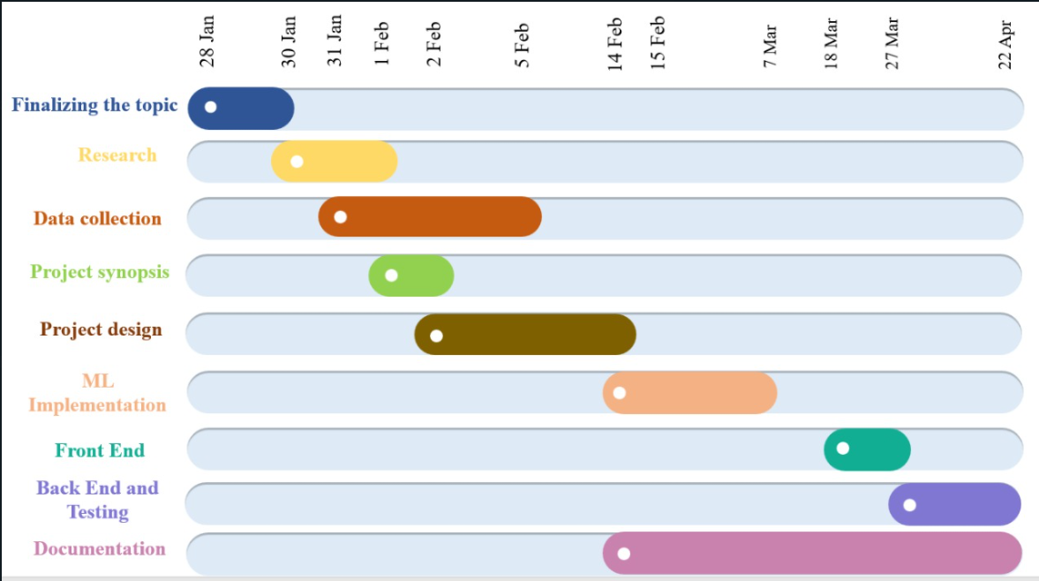

*Figure 2.2. Gantt Chart of project timeline*

1. **HARDWARE AND SOFTWARE REQUIREMENTS**
   1. **CPU AND MEMORY ANALYSIS**

For This project a 4 GB RAM is sufficient. The CPU and Memory usage is shown in the following figures. The following figure depicts the usage of CPU and Memory before and after the app is started for the project to run successfully.

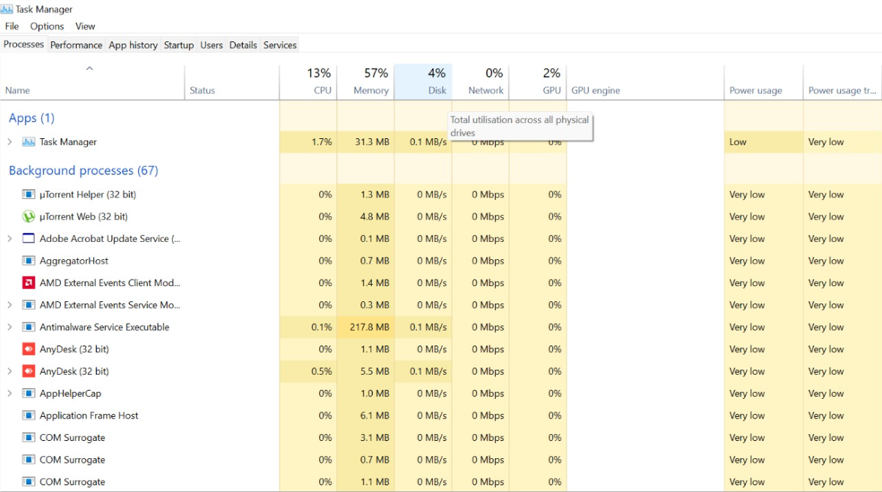

*Figure 3.1. CPU and Memory usage before starting project*

Figure 3.1. shows the CPU and memory usage before any applications are started. Initially it shows that the CPU usage is 13% and Memory usage is 57%. Here 31.3 MB is occupied by the Task Manager and remaining memory by the background processes.

Since we are using Pycharm Professional for creating the project, opening it.

The memory status is:

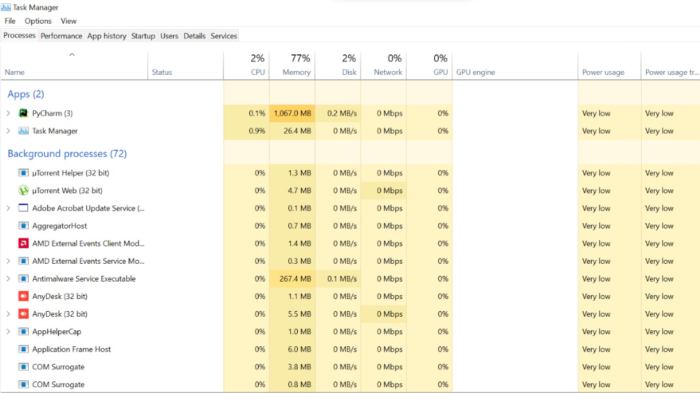

*Figure 3.2. CPU and Memory usage after opening Pycharm Professional*

Figure 3.2. shows the CPU and memory usage of Pycharm Professional. It shows that the CPU usage is 2% and Memory usage is 77%. Here 26.4 MB is occupied by the Task Manager, 1067.0 MB is occupied by the Pycharm and remaining memory by the background processes.

For running the Web developed we can use any browser like Firefox, Microsoft Edge, Google Chrome, Brave, etc. Here we are using Google chrome.

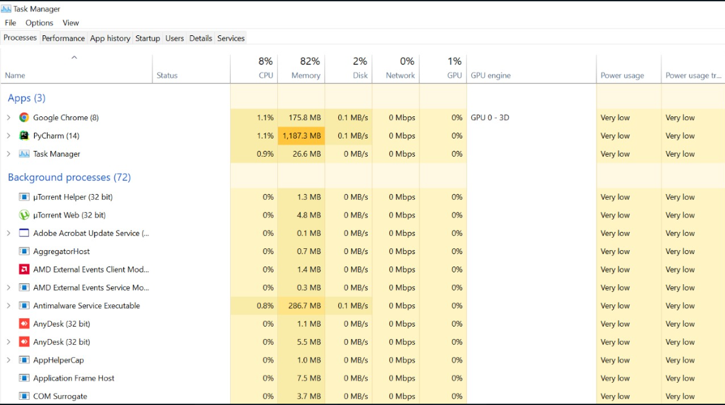

*Figure 3.3. CPU and Memory usage after opening Google Chrome*

Figure 3.3. shows the CPU and memory usage of Pycharm Professional. It shows that the CPU usage is 8% and Memory usage is 82%. Here 26.6 MB is occupied by the Task Manager, 1187.3 MB is occupied by the Pycharm, 175.8 MB is occupied by the Google Chrome web browser and remaining memory by the background processes.

Apart from this, we have done testing and training of our ML model using Jupyter Notebook, so if we run it in parellel the requirements are:

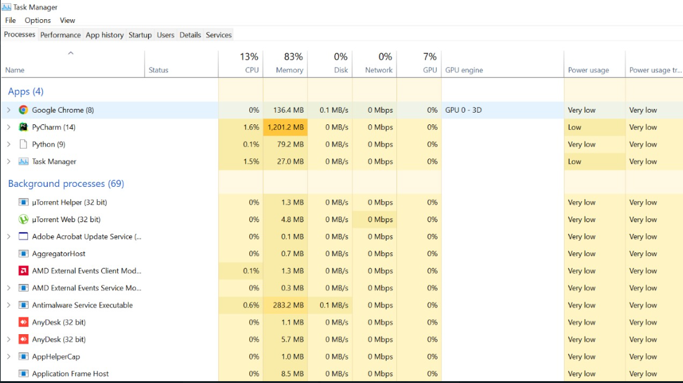

*Figure 3.4. CPU and Memory usage after opening Jupyter Notebook*

Figure 3.4. shows the CPU and memory usage of Pycharm Professional. It shows that the CPU usage is 13% and Memory usage is 83%. Here 27.0 MB is occupied by the Task Manager, 1201.2 MB is occupied by the Pycharm, 136.4 MB is occupied by the Google Chrome web browser, 79.2 MB is occupied by the Jupyter Notebook and remaining memory by the background processes.

* 1. **PYCHARM PROFESSIONAL**

PyCharm is an integrated development environment (IDE) used in computer programming, particularly for the Python programming language. It is a cross-platform, with Windows, macOS and Linux versions. The Community Edition is released under the Apache License, and there is also a Professional Edition with extra features.

It offers some of the best features to its users and developers in various aspects like Code completion and inspection, Advanced debugging and support for web programming and frameworks. such as Django and Flask.

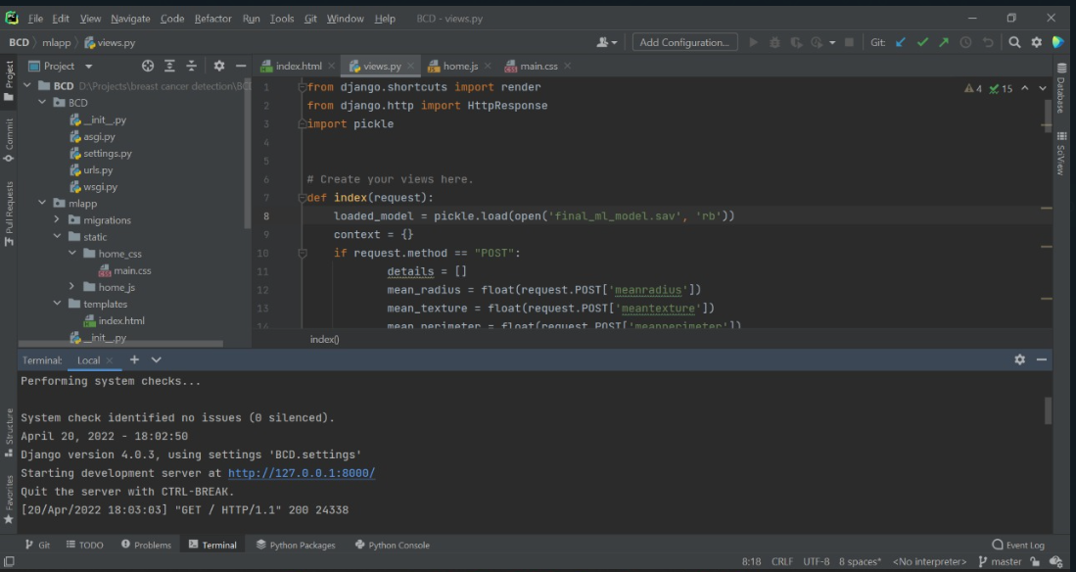

*Figure 3.5. Pycharm Environment*

* 1. **PYTHON PROGRAMMING**

Python is the fastest growing language in terms of developers, libraries and applications it can be used for. It could be used in Machine Learning, Artificial Intelligence, Web Development; anything we can think of, can be developed with python. Python is a general-purpose programming language which is high-level, easy to learn and dynamically initialized.

In python we used indentations instead of braces to display a block of code. Python is an easy and open-source language, it is free for everyone to use. Python can be used to make web applications, mobile applications, server-side scripting, AI, ML etc. There is a huge community of people who came together to develop libraries or modules that can be used to optimize solutions. It has huge Libraries for user support.

Here, as we are using Jupyter Notebook.

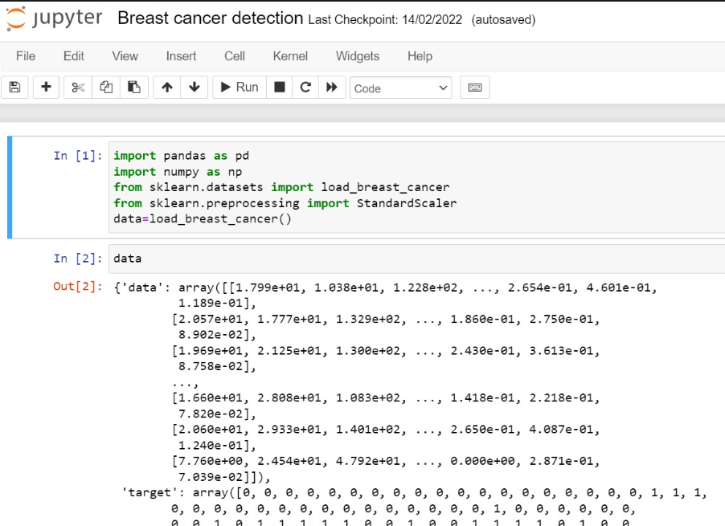

*Figure 3.6. Python Programming on Jupyter Notebook*

* 1. **DJANGO FRAMEWORK**

Django Framework is a combination of certain components and packages. If we want to build a complex application, there are certain things, we need readymade. Django is a famous open-source, web application framework. We need Django to create web application using Python Language. Django follow MVT architectural pattern. Model-view-template is used to build good web application. Django is fast and there are many components available. It is secure and scalable.

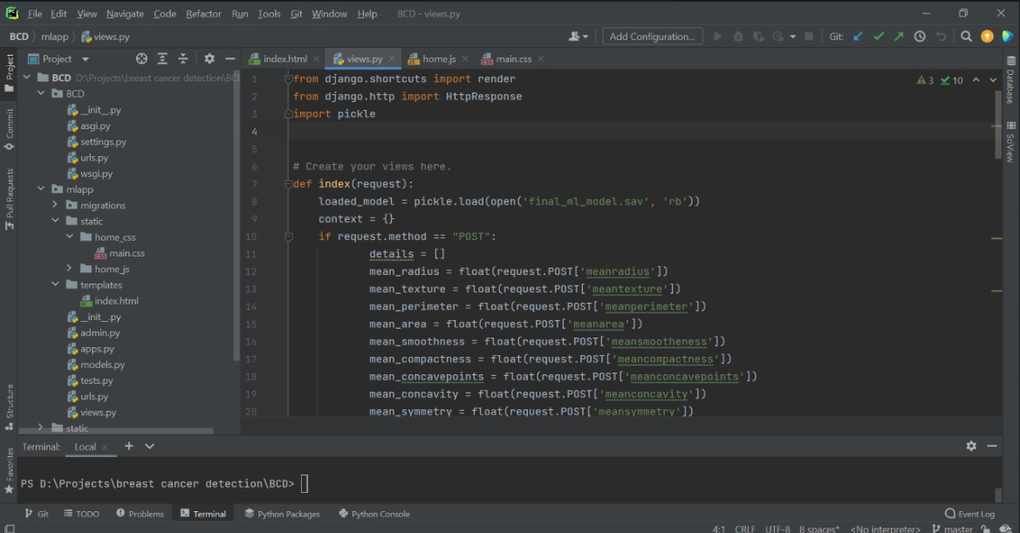

*Figure 3.7. Django Framework*

1. **IMPLEMENTATION WORK DETAILS**
   1. **REAL LIFE APPLICATIONS**

* Breast cancer is the most common cancer among women in 154 countries and the main cause of cancer-related death in 103 countries. The mortality rate Is approximately 15.0%.
* The early diagnosis of Breast Cancer can improve the prognosis and chance of survival significantly, as it can promote timely clinical treatment to patients.
* We have used techniques to make tools for doctors that can be used as an effective mechanism for early detection which could greatly enhance the survival rate of patients.
* Machine learning algorithms are used for medical oriented research, it advances the system, reduces human errors and lowers manual mistakes.
  1. **IMPLEMENTATION AND PROGRAM EXECUTION**

Following are the libraries and modules used in our project for predicting the breast cancer lump measurements using ML and creating the front-end web application:

* + 1. **Module pandas**

Pandas is a popular open-source Python-based data analysis toolkit which can be imported using import pandas as pd. It presents a diverse range of utilities, ranging from parsing multiple file formats to converting an entire data table into a NumPy matrix array. It provides ready to use high-performance data structures and data analysis tools. It is popularly used for data science. It allows us to store and manipulate tabular data as a 2-D data structure.

**pd.read_csv**(“ File name “) is used to read the csv file .

* + 1. **Module numpy**

NumPy is a Python package which stands for Numerical Python. It is a library consisting of multidimensional array objects and a collection of routines for processing those arrays. In python mathematical and logical operations on arrays can be performed using this module. The ‘np’ portion of the code then tells Python to give NumPy the alias of np. This allows you to use NumPy functions by simply typing np.

* + 1. **Module sklearn**

Scikit-learn is probably the most useful library for machine learning in Python. The sklearn library contains a lot of efficient tools for machine learning and statistical modelling including classification, regression, clustering and dimensionality reduction.

* **from sklearn.datasets**.~ in Python machine learning programming, we have software called scikit-learn. This software contains some small datasets that are very easy to access, one of which is the load_breast_cancer dataset and this is the syntax for loading dataset.
* **from skleran.preprocessing.**~ data preprocessing is a technique that is used to convert the raw data into a clean data set. The idea behind StandardScaler is that it will transform your data such that its distribution will have a mean value 0 and standard deviation of 1.
* **sklearn.model_selection.train_test_split** is used to split the data into testing and training data .
* **sklearn.linear_model.LogisticRegression** is used to train the model using the fit function. To predict from the model use the predict function.
* **sklearn.metrics.accuracy_score** is used to find out the accuracy of your model
  + 1. **Module matplotlib**

matplotlib.pyplot is a plotting library used to interface to matplotlib. It provides a way of plotting just like MATLAB. Also, it opens figures on the screen and acts as figure GUI manager.

pyplot is majorly used for interactive plots like Line plot, Histogram, Polar, 3D plot etc. and simple cases of programmatic plot generation. Matplotlib is generally used for user interface toolkits like Tkinter etc.

* + 1. **HTML**

HTML stands for Hyper Text Markup Language, is the most basic building block of the Web. It is the standard markup language for documents designed to be displayed in a web browser. "Hypertext" refers to links that connect web pages to one another, either within a single website or between websites. HTML uses "markup" to annotate text, images, and other content for display in a Web browser.

* + 1. **CSS**

CSS is used for styling the page created by html. It stands for **Cascading Style Sheet.** It describes how HTML element are to be displayed on screen, paper, or in other media. Usually HTML is all about ‘what to display?’ but CSS is all about ‘how to display?’ Writing CSS is a bit complicated as compared to HTML. CSS is an ART!

* + 1. **Bootstrap**

Bootstrap is a CSS based Front end Framework created by twitter. We can create Layout, Typography, Navigation Menu, Form Layout, Buttons, Pagination, Icon fonts and Responsiveness. Work becomes faster and easier using bootstrap. It is easy to create responsive web layouts using bootstrap.

* + 1. **JavaSript**

JavaScript is the world's most popular programming language of the Web. It is easy to learn. In this project we have used JS only for certain parts of Website that need dynamic animations, i.e., navbar and carousels taken by Bootstrap Free Frontend.

* + 1. **XAMPP**

XAMPP is a completely free, easy to install Apache distribution containing MySQL, PHP and PERL. The XAMPP open-source package has been set up to be incredibly easy to install and use. XAMPP stands for Cross-Platform (X), Apache (A), MariaDB (M), PHP (P) and Perl (P). Here we have already created connection of project to store all the data we are testing on the website, using XAMPP we can further create the models to store it all if required and view it on PhpMyAdmin on browser. We can also use WAMPP or other services if XAMPP is not used.

1. **STIMULATION CODE**
   1. **Importing required modules**

Following modules are imported in the code:

1. Pandas: The Pandas module mainly works with the tabular data, which is required to train the ML model.
2. NumPy: The NumPy module works with numerical data, basically used in manipulating and making it fit for the ML model.
3. Sklearn: Scikit-learn is a free software machine learning library for the Python programming language. It features various classification, regression and clustering algorithms.
4. Matplotlib: Matplotlib is a plotting library for the Python programming language and its numerical mathematics extension NumPy. It provides an object-oriented API for embedding plots into applications.
5. Pickle: Python pickle module is used for serializing and de-serializing a Python object structure.
   1. **Logistic Regression model:**

Logistic Regression is one of the machine learning algorithms used for solving classification problems. It is used to estimate probability whether an instance belongs to a class or not. If the estimated probability is greater than threshold, then the model predicts that the instance belongs to that class, or else it predicts that it does not belong to the class as shown in fig 1. This makes it a binary classifier. Logistic regression is used where the value of the dependent variable is 0/1, true/false or yes/no.

Output = 0 or 1

Hypothesis => Z = WX + B

hΘ(x) = sigmoid (Z)

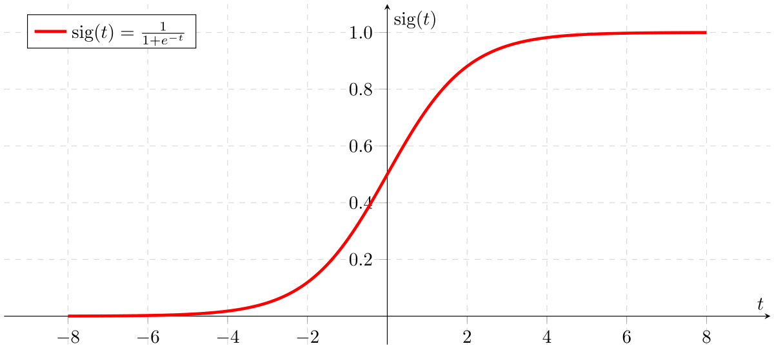

*Figure 5.1. Sigmoidal Function in Logistic Regression*

If ‘Z’ goes to infinity, Y(predicted) will become 1 and if ‘Z’ goes to negative infinity, Y(predicted) will become 0. In our project, Logistic regression is used as:

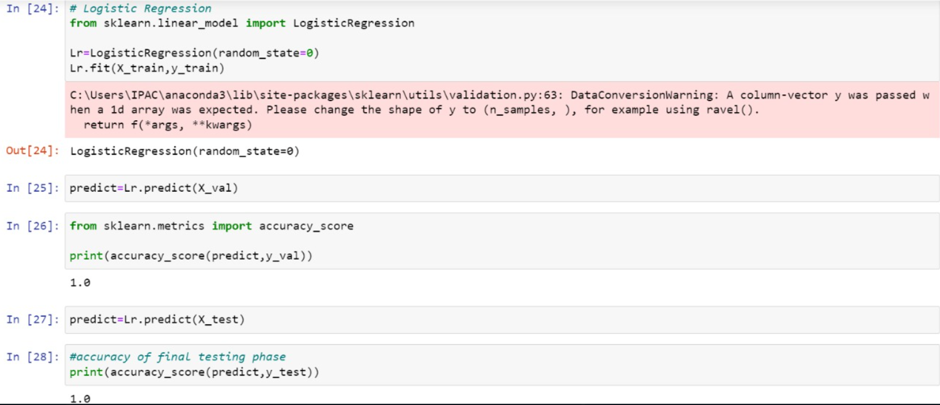

*Figure 5.2. Code snippet of Logistic Regression*

* 1. **Support Vector Machine**

“Support Vector Machine” (SVM) is a supervised machine learning algorithm that can be used for both classification or regression challenges. In the SVM algorithm, we plot each data item as a point in n-dimensional space (where n is a number of features you have) with the value of each feature being the value of a particular coordinate. Then, we perform classification by finding the hyper-plane that differentiates the two classes very well.

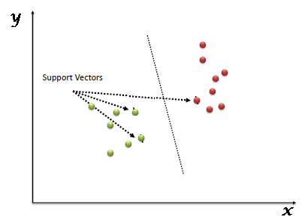

*Figure 5.3. Hyper plane in SVM*

In our project, we implemented SVM as:

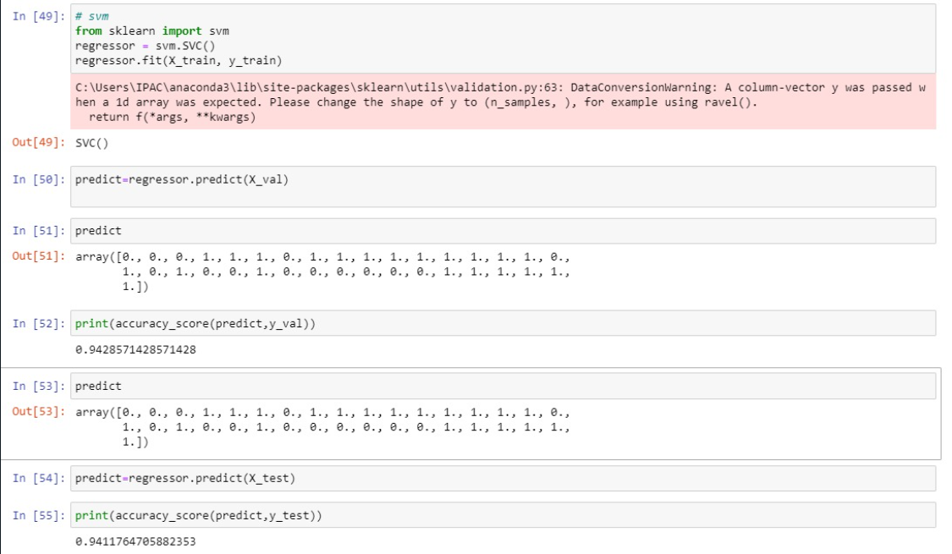

*Figure 5.4. Code snippet of SVM*

* 1. **Random forest classifier**

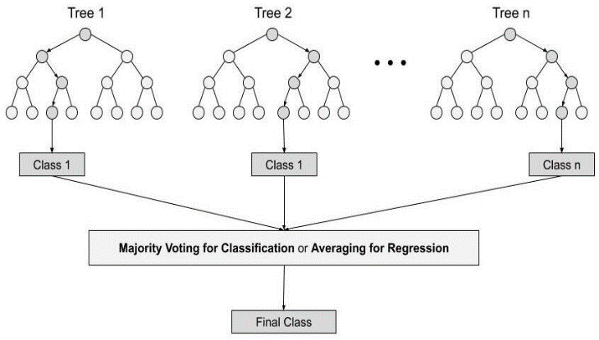Random forest is a Supervised Machine Learning Algorithm that is used widely in Classification and Regression problems. It builds decision trees on different samples and takes their majority vote for classification and average in case of regression.

One of the most important features of the Random Forest Algorithm is that it can handle the data set containing continuous variables as in the case of regression and categorical variables as in the case of classification. It performs better results for classification problems.

Figure 5.5. Random Forest Classification

In our project we have implemented Random Forest classifier as:

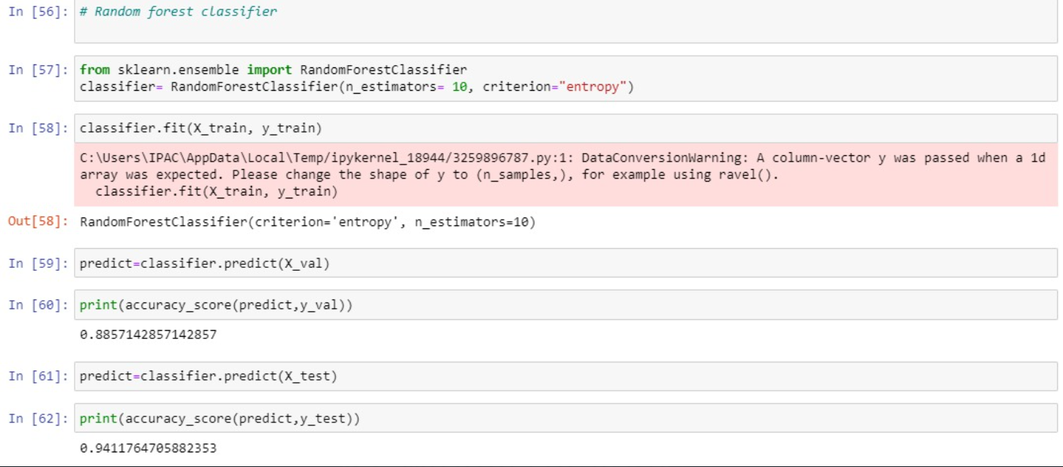

*Figure 5.6. Code snippet of Random Forest Classifier*

Here is the whole walkthrough of how we built our machine learning model. First we loaded and manipulated the data. The clean data is then fitted into our model to train it. Later, the model with highest accuracy was chosen and used in Django project, which created a .sav file when loaded, and using predict, the values can result in the message to be displayed as output.

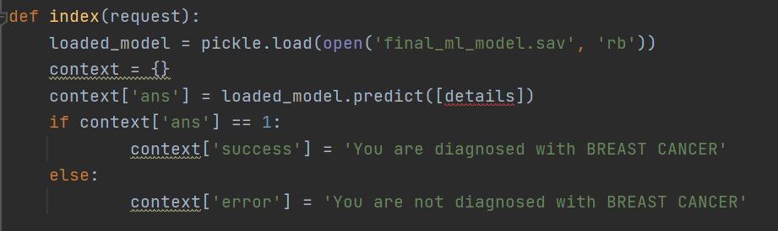

*Figure 5.7. Snippet of Linking Logistic regression model to Django*

* 1. 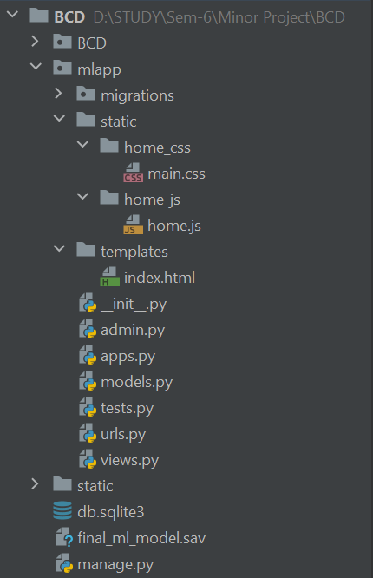**Django Basic setup of starting an app**

Starting a Django project, we create the following files shown:

* Here mlapp is the web app we have created.
* In static folder: the css file and js file for the front end is present.
* In templates folder: the html file is created; they can be one or multiple.
* Here index.html is our web page
* In models.py: the tables to store data checked on the frontend are created to link it directly to phpMyAdmin.
* In settings.py: the ml app implemented is registered

Figure 5.7. Django files

* In urls.py: the path for html page is declared
* In views.py: the backend coding is done which is linked to index.html
* The db.sqlite3: folder in the end is created after making migrations which shows that the project is ready to be connected to backend [using XAMPP and SQLite for it if required]
* The final_ml_model.sav: gets created using pickle and loading the logistic regression model in the project to predict results.
  1. **Django Frontend in index.html components**
     1. **Navbar and Banner**

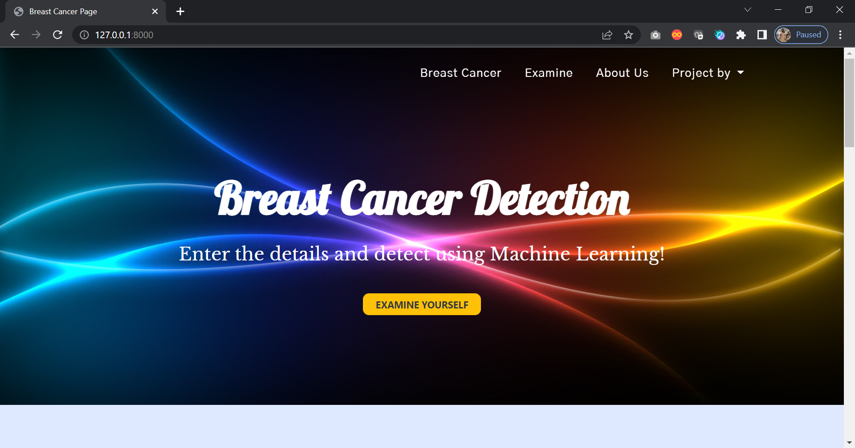

Figure 5.8. Webpage Snippet Part I

The navbar is static even on smooth scrolling. It has 4 components: breast cancer, examine, about us and project created by [the credits]. The breast cancer navigates us to general information regarding this disease in the carousal below. Examine leads to the test yourself section and about us to the footer respectively.

The banner gives a beautiful look to the website the moment it is open. It displays the title and purpose of the website. The Examine Yourself button here also directs us to the Table section below.

* + 1. **Carousel**

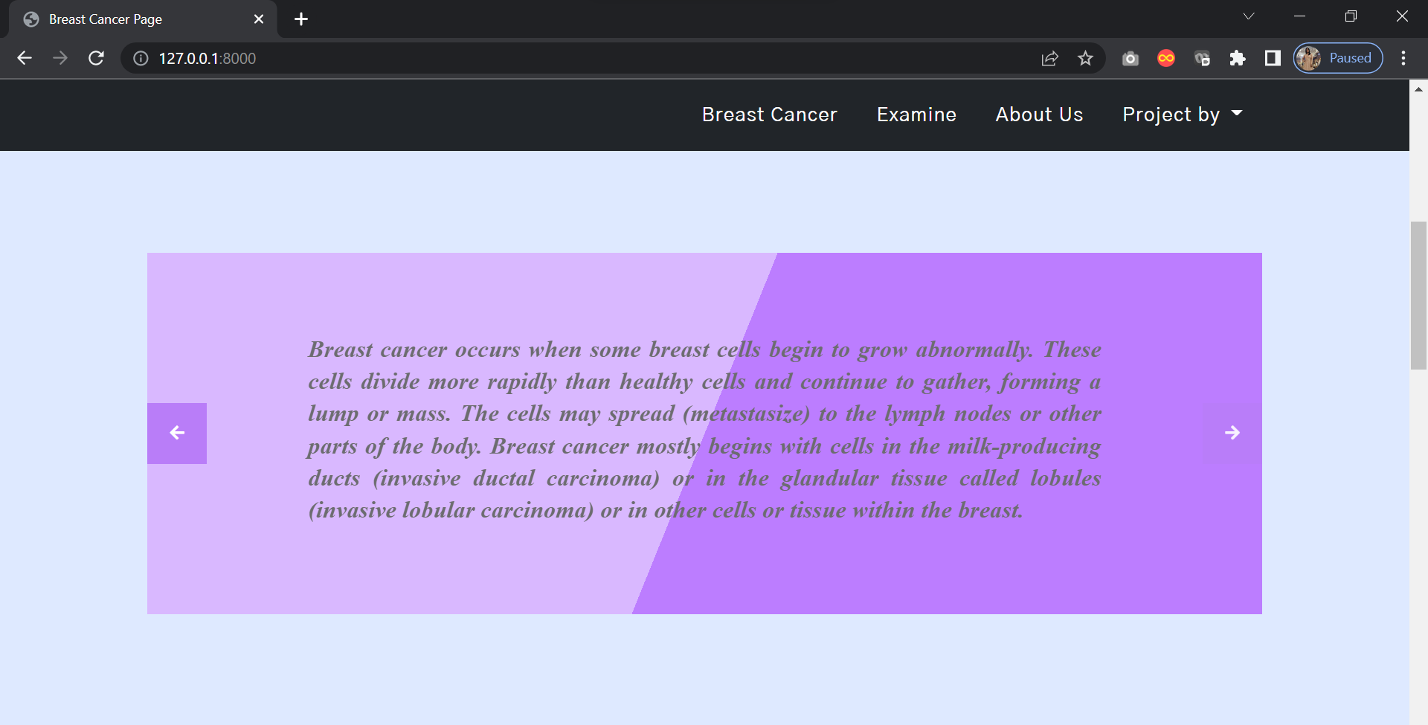

Figure 5.9. Webpage Snippet Part II

The carousel is sliding in every 5 seconds and provides basic information about breast cancer to everyone on the webpage. The arrows can be used to read the desired slide.

* + 1. **Table**

The table to input the required parametric data to detect breast cancer lump. On pressing the button one can view results after filling the data in every field asked.

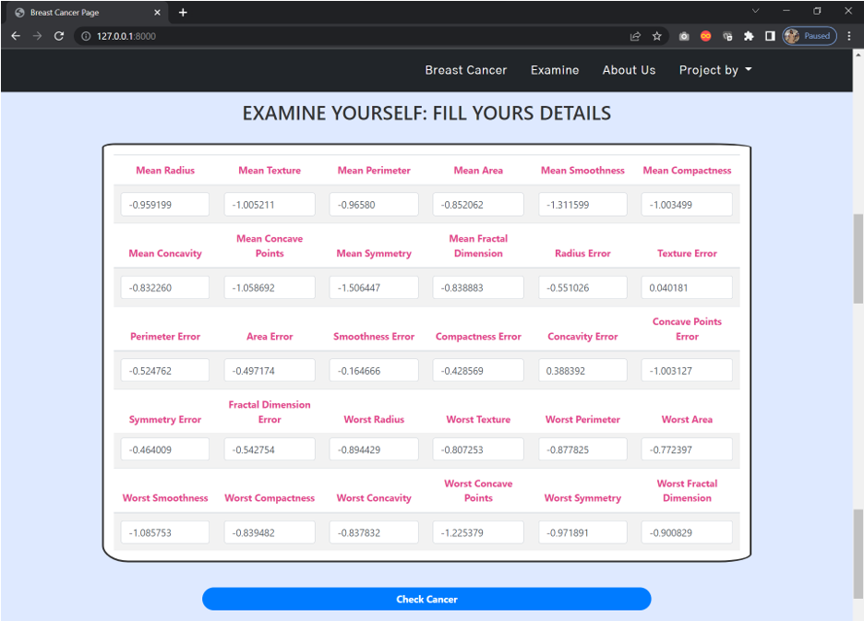

Figure 5.10. Webpage Snippet Part III

* + 1. **Result**

The result is seen as a breadcrumb message which appears when we click on the Check Cancer button after filling all the entries above as:



Figure 5.11. Webpage Snippet Part IV

* + 1. **Footer**

This is a footer to provide with the concerned people’s details in case of queries regarding the website when it will be deployed. It can be modified according to future needs when the website is deployed.

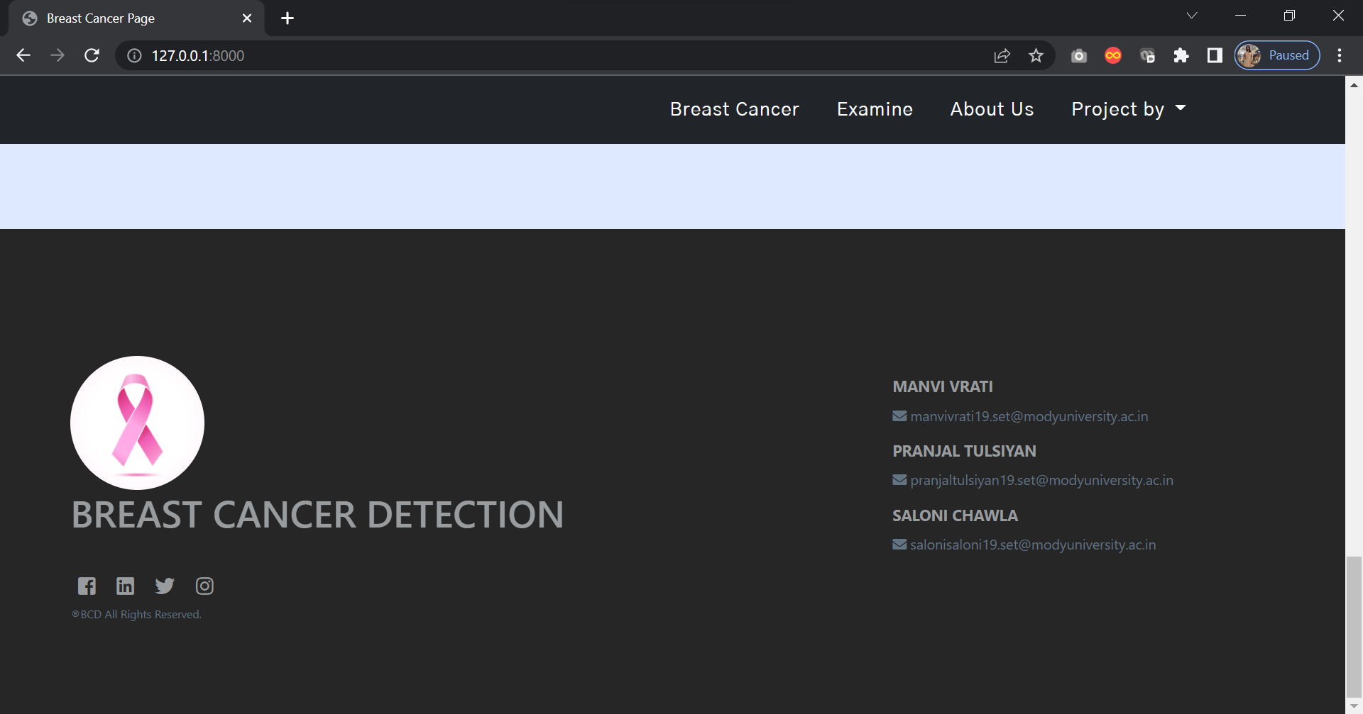

Figure 5.12. Webpage Snippet Part V

* 1. **Django Backend created in views.py**

The backend coding is done in Django views.py file. It is linked to the webpage using same names as there in the index.html:

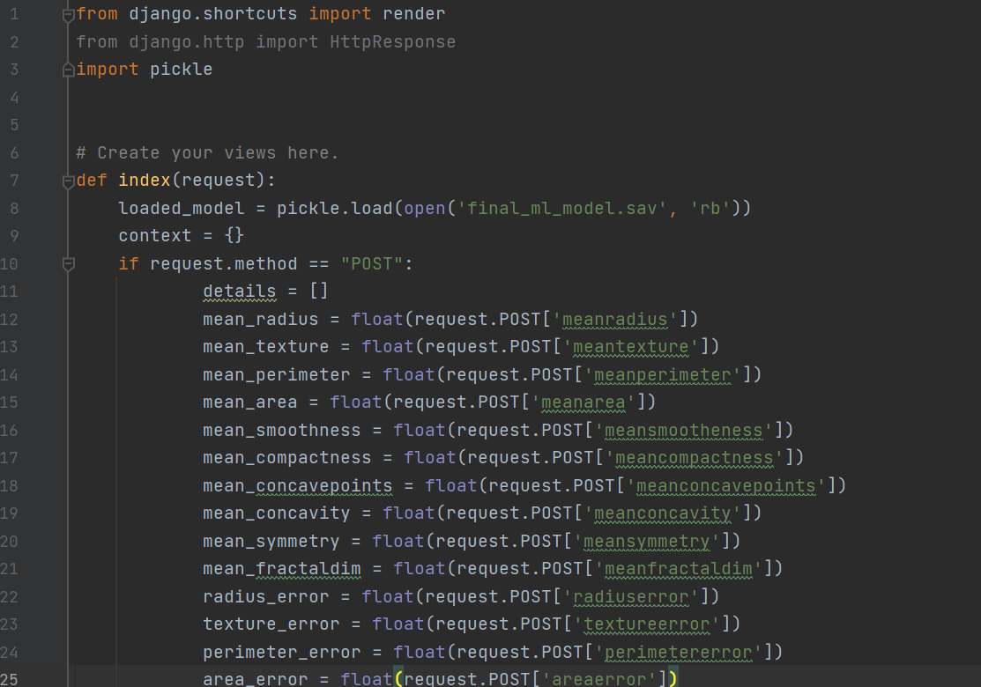

……

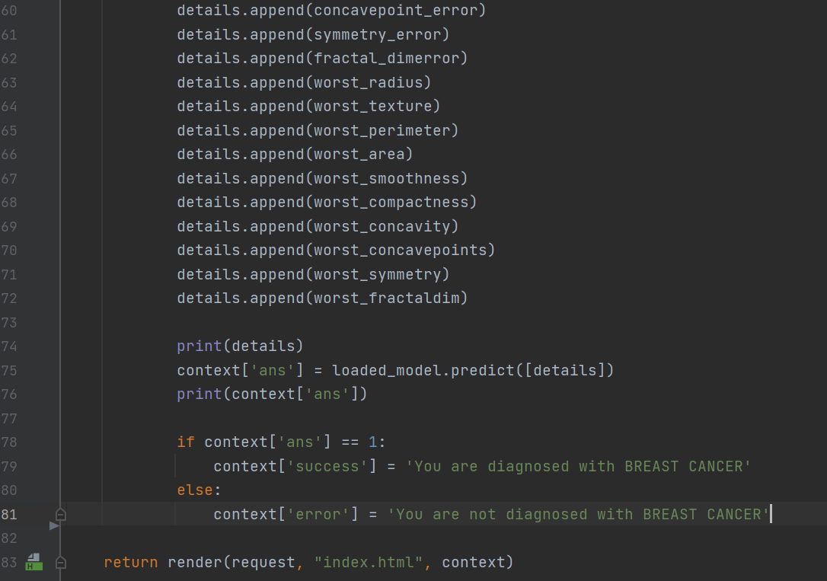

*Figure 5.13. Backend in views.py*

1. **SYSTEM TESTING**

In this project, we have done the manual testing to test the application. In **Manual testing**, test-cases are executed normally by all the team members, i.e., without any support from tools or scripts. We have to ensure that the application is working properly based on the written test cases. We need to evaluate numerous components like design, functionalities and performance by clicking through multiple elements of the website. With Manual testing tester can test the application under similar condition when the application goes live. Any bugs or glitches or errors which occur when application is live can be tracked with the help of manual testing, though there can be a possibility that not all errors are fixed, as the process is manual and not machine operated. For these circumstances, we can work on suggestions provided by users and implement fixing those bugs in the next version of the site.

Following are the two cases possible:

* **When you are detected with breast cancer:**

Figure 6.1. below shows the parametric values taken from the database which are denoting the lump that can be cancerous. Once we click on the check cancer button below it the page loads the result by using the model and we get the message on the top [below navbar] as shown in Figure 6.2. that “You are diagnosed with BREAST CANCER”.

* **When you are not detected with breast cancer:**

Figure 6.3. below shows the parametric values taken from the database which are denoting the lump that cannot be cancerous. Once we click on the check cancer button below it the page loads the result by using the model and we get the message on the top [below navbar] as shown in Figure 6.4. that “You are not diagnosed with BREAST CANCER”.

Following are the output snippets:

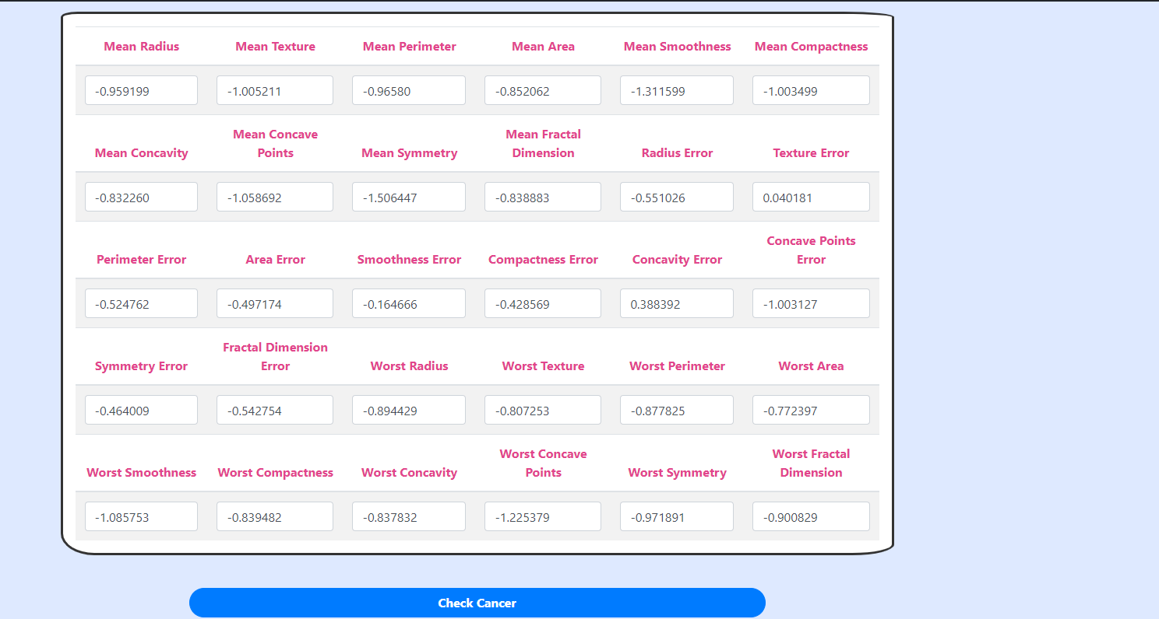

*Figure 6.1. When Diagnosed with Breast Cancer [Values]*

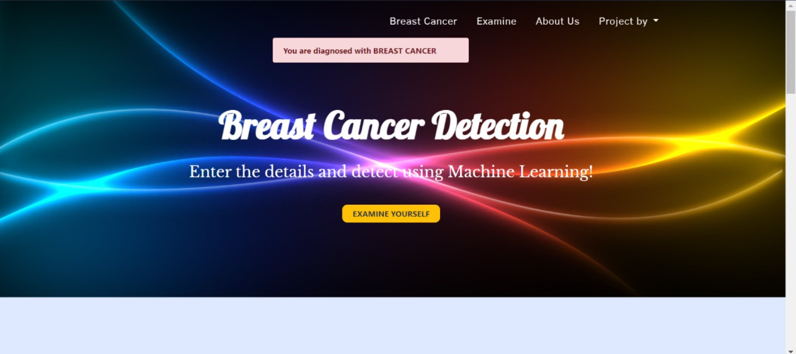

*Figure 6.2. When Diagnosed with Breast Cancer [Result]*

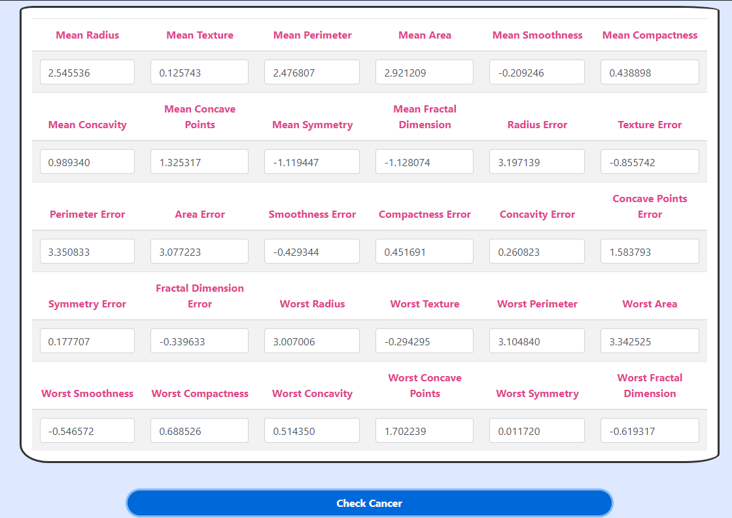

*Figure 6.3. When Not Diagnosed with Breast Cancer [values]*

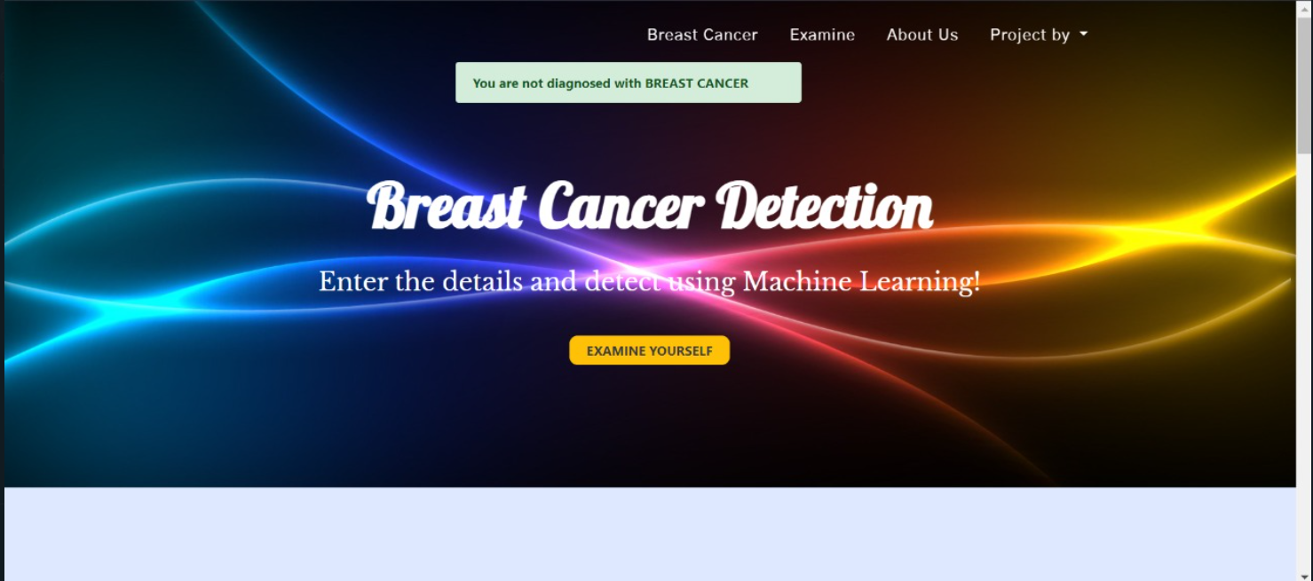

*Figure 6.4. When Not Diagnosed with Breast Cancer [Result]*

1. **INDIVIDUAL CONTRIBUTION**

All the members in the team worked separately and the changes were pushed in the git directory. Hence the project was completed when we were all connected through google meet. We read about ML together, explored libraries and functions and completed the code together. At the end we implemented frontend using Django together. Even the documentation was done in parts by everyone. Therefore, the project was completed with equal efforts made by all the team members.

* **Manvi Vrati [190136]:**

I have particularly worked with Logistic regression in ML. I also created the Django front end webpage of our project. I worked majorly in importing the library with highest accuracy into our Django Project. For documentation I majorly contributed for Front end implementation [web page] in the report.

* **Pranjal Tulsiyan [190119]:**

I have particularly worked with Support Vector Machine in ML. I also started Django project for further updations like creating the urls, settings and views files. I worked majorly in creating the code for backend as well. For documentation I majorly contributed for Django implementation in the report.

* **Saloni Chawla [190078]:**

I have particularly worked with Random Forest in ML. While working with data on Jupyter I did the data pre-processing for testing and training. I contributed in searching front end elements and testing of data in our webpage for accurate results. For documentation I majorly contributed for ML implementation in the report.

Everyone contributed equally for making the presentation to display. Since we have done manual testing, everyone performed hit and trial to obtain limitations and outcomes of our application. Everyone equally contributed in searching matter for documentation.

Due to the teamwork, together we have completed the project successfully.

1. **CONCLUSION**

In this project with the help of ML, we have built a model which detects breast cancer with the help of the features of the lump provided. Breast cancer is the most common cancer among women in 154 countries and the main cause of cancer-related death in 103 countries. In 2018, there were approximately 2.1 million new cases of breast cancer in women, accounting for 24.2% of the total cases, and the mortality rate was approximately 15.0%. The early diagnosis of Breast Cancer can improve the prognosis and chance of survival significantly, as it can promote timely clinical treatment to patients.

|  |  |  |
| --- | --- | --- |
| **Algorithms** | **Accuracy Training Set (%)** | **Accuracy Testing Set (%)** |
| Logistic Regression | 100% | 100% |
| Support Vector Machine | 94.28% | 94.11% |
| Random Forest | 88.57% | 94.11% |

* 1. **LIMITATIONS**

In this project, we have 100% of accuracy of Logistic Regression model used after all the testing training of data. So, if there is any loop hole in results it will be due to error in Logistic Regression model only. It will keep improving itself as the data keeps growing. The only limitation in the project is that we are working on parametric data and not on pictorial data that can read CT scans directly.

* 1. **SCOPE FOR FUTURE WORK**

Currently the project is running on our machines only as the project is not deployed. Also we can use other ML libraries that can read CT scans as well to work on pictorial data which is more convinient for us. So future scope of the project is to deploy it globally and include code to read pictorial data as well.

1. **BIBLIOGRAPHY**
2. Esther Shein,*Python for beginners,* February 12,2015. Accessed on: Jan 29,2021. [Online]. Available:<https://www.researchgate.net/publication/276442047_Python_for_beginners>
3. Manish Bhatt, *Machine Learning Project*, May 26,2016. Accessed on: Feb 1,2021. [Online]. Available: <https://www.researchgate.net/publication/303326261_Machine_Learning_Project>
4. “*Pyplot in Matplotlib*”, Accessed on: November 20, 2021. [Online].Available: [Pyplot in Matplotlib - GeeksforGeeks (ampproject.org)](https://www-geeksforgeeks-org.cdn.ampproject.org/v/s/www.geeksforgeeks.org/pyplot-in-matplotlib/amp/?amp_js_v=a6&amp_gsa=1&usqp=mq331AQKKAFQArABIIACAw%3D%3D#aoh=16380218424052&referrer=https%3A%2F%2Fwww.google.com&amp_tf=From%20%251%24s&ampshare=https%3A%2F%2Fwww.geeksforgeeks.org%2Fpyplot-in-matplotlib%2F)
5. *“Web-based document or source - IEEE Referencing - Library Guides at Victoria University”*, Feb 27, 2022. Accessed on: April 22, 2021.[Online]. Available: <https://libraryguides.vu.edu.au/ieeereferencing/webbaseddocument>
6. *“Installation - Material UI”*, Nov 12,2018. Accessed on: March 16,2022. [Online]. Available: <https://mui.com/getting-started/installation/>
7. *“Django Tutorial”,* Dec 4, 2015. Accessed on: March 20, 2022. [Online]. Available: <https://www.w3schools.com/django/index.php>
8. [Gayathri Devi Nagalapuram](https://medium.com/@gayathri1462?source=post_page-----ceec26193fb6--------------------------------), *Breast Cancer Prediction using Machine Learning (Part-1),* Jan 7, 2021. Accessed on: Jan 6, 2022. Available: [https://medium.com/breast-cancer-prediction-using-machine-learning](https://medium.com/analytics-vidhya/breast-cancer-prediction-using-machine-learning-part-1-ceec26193fb6)
9. [Kaustumbh Jaiswal](https://medium.com/@kaustumbhjaiswal7?source=post_page-----6c7de05c8d7--------------------------------), *How to deploy a Machine Learning model using Django: Part-1,* June 15, 2017. Accessed on: Feb 12, 2022. Available: [https://medium.com/deploying-a-machine-learning-model-using-django](https://medium.com/saarthi-ai/deploying-a-machine-learning-model-using-django-part-1-6c7de05c8d7)
10. **ANNEXURES**

Plagiarism report